PROJECT Console Programming with Python - Tic Tac Toe Game

Objective To use Python to demonstrate a game - based Console Application.

PROJECT DESCRIPTION

Create and code a Python application for the following scenario:

a TIC TAC TOE game

Follow the steps below to design and create this game application.

Wishing you a successful gameplay!

Information About This Project

The initial game screen consists of nine sequentially numbered slots, placed in a grid - like display.
[ Initial Game Screen ]

1 | 2 | 3
4 | 5 | 6
7 | 8 | 9

[ The Sample Game Play ]

First Move: The X's Player begins the game and enters this slot number → 1

Second Move: To counteract, the O's Player then enters this slot number → 3

Third Move: The X's Player strikes again and enters this slot number → 9

Fourth Move: To counteract, the O's Player then enters this slot number → 7

Fifth Move: The X's Player now moves and enters this slot number to win → 5

[ The " X " Player Wins! ]

X | 2 | 0
4 | X | 6
O | 8 | X

Steps to Complete This Project

STEP 1 Open a Web Browser

Launch a Web Browser on your computer, such as Microsoft Edge, MAC Safari, Google Chrome, Firefox, Mozilla, etc.

STEP 2 Travel to a Web Link

Navigate to the Web site that is given by the link below.

Online Python Compiler - online editor (onlinegdb.com)

STEP 3 Observe the Initial Code Statements

At the above Web site, view the given test code that is provided.

'''

Welcome to GDB Online.
GDB online is an online compiler and debugger tool for C, C++, Python, Java, PHP, Ruby, Perl,
C#, OCaml, VB, Swift, Pascal, Fortran, Haskell, Objective-C, Assembly, HTML, CSS, JS, SQLite, Prolog.
Code, Compile, Run and Debug online from anywhere in world.

'''
print ('Hello World')

STEP 4 Copy the Program Code

Highlight and delete all the code statements that are initially provided at the above Web site.

Then, copy all the program code statements that are given in Figure 1 , which follows.

Be sure to copy just the code statements and to include all the statements.

Figure 1 Program Code: TIC TAC TOE

board = [" " for _ in range(9)]
turn = "X"
winner = None

def populateEmptyBoard():
global board
board = [" " for _ in range(9)]

def printBoard():
print("----------------------")
print("|", board[0], "|", board[1], "|", board[2], "|")
print("----------------------")
print("|", board[3], "|", board[4], "|", board[5], "|")
print("----------------------")
print("|", board[6], "|", board[7], "|", board[8], "|")
print("----------------------")

def checkWinner():
global winner
# Check rows
for i in range(0, 9, 3):
if board[i] == board[i+1] == board[i+2] != " ":
winner = board[i]
return

# Check columns
for i in range(3):
if board[i] == board[i+3] == board[i+6] != " ":
winner = board[i]
return

# Check diagonals
if board[0] == board[4] == board[8] != " ":
winner = board[0]
return
if board[2] == board[4] == board[6] != " ":
winner = board[2]
return

# Check for draw
if " " not in board:
winner = "draw"

def playGame():
global turn
print("Two Player TIC TAC TOE")
print("----------------------")
printBoard()
print("The X's will play first")
print("Enter a slot number to place an X in => ")

while winner == None:
try:
numInput = int(input())
if not (numInput > 0 and numInput <= 9):
print("Invalid Input! Re-enter the slot number:")
continue
except ValueError:
print("Invalid Input! Re-enter the slot number:")
continue

if board[numInput-1] == " ":
board[numInput-1] = turn
printBoard()
checkWinner()
if winner:
break
if turn == "X":
turn = "O"
else:
turn = "X"
else:
print("Slot is already taken! Re-enter a slot number:")

if winner == "draw":
print("The game is a draw! Thanks for playing.")
else:
print("Congratulations! " + winner + " has won! Thanks for playing.")

populateEmptyBoard()
playGame()

After you have copied the program code into that online compiler, click the
[ Run ] button there to execute the program.

An output screen such as shown below will then appear.

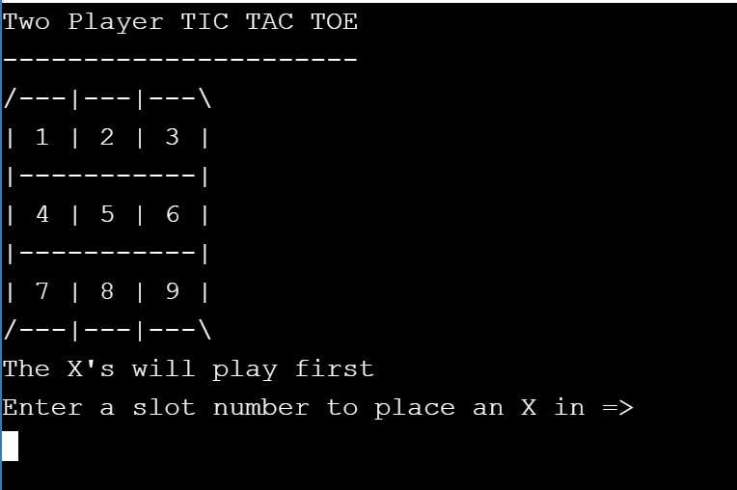

A sample screen snapshot of the game play is given below.

STEP 6 Play the Game

After you compile your program, run the program with multiple executions using each of these three scenarios.
A sample run is shown in Figure 2 , which follows.
_________________________________________________________________

Scenario One

player X wins the game

Scenario Two

player O wins the game

Scenario Three

the game ends in a " draw " or tie
_________________________________________________________________

Figure 2 Program Output: TIC TAC TOE

Two Player TIC TAC TOE
----------------------
/---|---|---\
| 1 | 2 | 3 |
|-----------|
| 4 | 5 | 6 |
|-----------|
| 7 | 8 | 9 |
/---|---|---\

The X's will play first
Enter a slot number to place an X in => 1

O's turn; enter a slot number to place O in: 2

X's turn; enter a slot number to place X in: 5

O's turn; enter a slot number to place O in: 9

X's turn; enter a slot number to place X in: 6

O's turn; enter a slot number to place O in: 7

X's turn; enter a slot number to place X in: 4

/---|---|---\
| X | O | 3 |
|-----------|
| X | X | X |
|-----------|
| O | 8 | O |
/---|---|---\

Congratulations! X's has won! Thanks for playing.
_______________________________________________________________________________
STEP 7 For Further Exploration

For further discussion, here are some intriguing questions for pondering that concern this application.

(1) Consider the various categories of electronic and non - electronic games.
How would you classify a TIC TAC TOE game? Explain your answer.

(2) What are the allowed player moves for a TIC TAC TOE game?

(3) What is the minimum number of moves that a player can make to win at TIC TAC TOE ? What are the maximum number of moves that can be made by an individual player?

(4) Let us now think in three - dimensions! Is it possible to construct a 3D version from the usual TIC TAC TOE game? Explain your answer.

(5) Consider a game of chess and consider a game of hearts for playing cards.
How do the player moves of chess and hearts differ from a TIC TAC TOE game?
Why is a TIC TAC TOE game referred to as a zero - sum game?

